**DECLARATION**

I hereby certify that the project work entitled **“Javascript Development”** in partial fulfilment of the requirements for the award of the Degree of bachelor of technology in Computer Science and Engineering as evaluation of Internship III is submitted to the Department of Computer Science & Engineering at Institute of Technology Gopeshwar, is an authentic record of our work carried out during a period of 10 July 2024 to 10 August 2024.

The matter presented in this project has not been submitted by us for the award of any other degree of this or any other University.

This is to certify that the above statement is correct to the best of my knowledge.

Raj Kishor (211340101032)

Date: 20 December 2024

**CERTIFICATE**

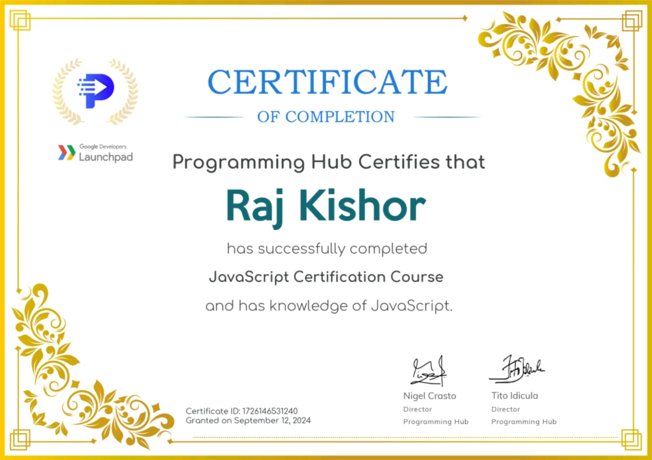

**ACKNOWLEDGEMENT**

I have taken effort in this summer training. However, it would not have been possible without the kind support and help of many individuals and organizations. I would like to extend my sincere thanks to all of them. I am highly indebted to Programming Hub for providing this online course platform.

I would like to express my sincere gratitude to Institute of Technology Gopeshwar for providing me with the opportunity to pursue my academic endeavors in an environment of excellence.

I extend my deepest thanks to Dr.Amit Agarwal, the esteemed Director of Institute of Technology Gopeshwar, for providing a supportive and resourceful environment that made this endeavor possible.

I would also like to extend my deepest thanks to my Head of Department, Mr. Varun Prabhakar, for their constant guidance, support, and encouragement throughout my course of study.

The knowledge and skills I have gained during this internship would not have been possible without the invaluable support of the college and my HOD. I am genuinely grateful for their contributions to my growth.

**ABSTRACT**

The JavaScript Internship at Programming Hub is a comprehensive program designed to equip participants with essential skills and knowledge in web development using JavaScript. This internship provides a thorough understanding of core JavaScript concepts, including variables, data types, functions, and object-oriented programming, as well as advanced topics such as asynchronous programming, DOM manipulation, and event handling.

Through hands-on projects and practical exercises, participants will gain proficiency in building interactive web applications, enhancing their problem-solving abilities and coding skills. Completing this internship not only solidifies foundational JavaScript knowledge but also prepares candidates for real-world programming challenges. This experience serves as a valuable stepping stone for aspiring developers, enabling them to pursue further opportunities in web development and related fields.

**LIST OF FIGURES**

|  |  |
| --- | --- |
| 1.2 Javascript logo | 1 |
| 1.2 Async & Sync JS | 6 |
| 4.1 Document Object Model | 7 |
| 5.2 Advance Module | 11 |
| 6.1 Integration in Web Development | 13 |
| 7.1 Snapshot of Music Listenter | 17 |
| 7.2 Snapshot of Weather App | 18 |

**CONTENT**

|  |  |
| --- | --- |
| Declaration | ii |
| Acknowledgement | iii |
| Certificate | iv |
| Abstract | v |
| List of Figures | vi |
| Table of Content | vii-viii |
| CHAPTER 1: Introduction  1.1 Overview of JavaScript  1.2 Importance of JavaScript in Web Development  1.3 JavaScript Engines  1.4 JavaScript Frameworks and Libraries  1.5 Development Tools and Environments |  |
| CHAPTER 2: JavaScript Fundamentals  2.1 Variables and Data Types  2.2 Operators  2.3 Control Structures  2.4 Functions  2.5 Scope and Hoisting  2.6 Error Handling |  |
| CHAPTER 3: Asynchronous JavaScript  3.1 Callbacks  3.2 Promises  3.3 Async/Await  3.4 Fetch API |  |
| CHAPTER 4: Document Object Model (DOM)  4.1 Understanding the DOM  4.2 DOM Manipulation  4.3 Event Handling  4.4 Working with Forms |  |
| CHAPTER 5: Advanced JavaScript Concepts  5.1 Closures  5.2 Modules  5.3 IIFE (Immediately Invoked Function Expressions)  5.4 Functional Programming Concepts |  |
| CHAPTER 6: JavaScript in Web Development  6.1 Integrating JavaScript with HTML and CSS  6.2 AJAX and Fetch for Asynchronous Requests  6.3 JavaScript Frameworks (React, Angular, Vue)  6.4 Testing and Debugging JavaScript Code |  |
|  |  |
| CHAPTER 7: Project  7.1 Music listener project  7.2 Weather app |  |
| Conclusion |  |
| References |  |